

Fourth Degree exemplification
november 12, 2022
Honoring:
Sir knight Louis Graziano

HOSTED BY
Fr. Walter L. DiFrancesco, Assembly 3493, Grovetown, Georgia
Georgia Degree Team
District Master – Georgia – Brad Burnett

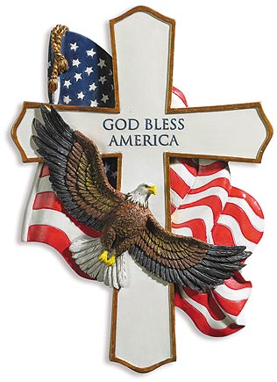

SCHEDULE OF EVENTS
8:30 - 9:30 Mass
10:00 – 11:00 Registration
11:00 – 12:30 pm. Exemplification
12:30 – 1:30 Lunch
(Observers-$10.00, include names and fees with candidate’s registration)
St. Teresa of Avila, Sacred Heart
4921 Columbia Road, Grovetown, GA 30813

INFORMATION FOR CANDIDATE
* Candidate fee to participate is $70.00
∗ This includes: Social Baldric
∗ 4th Degree Membership Pin
∗ .Certificate suitable for framing

PLEASE NOTE:
IN ORDER TO ENSURE CERTIFICATES ARE CORRECT, WE ASK THAT All
COMPLETED FORM 4 AND ALL FUNDS BE RECEIVED NO LATER THAN 10 DAYS PRIOR TO THE EVENT.

MAKE CHECKS PAYABLE TO: Georgia Master Fund
AND MAIL TO: Jerry Mock, District Secretary, 12 Pine Court Carrollton, Ga. 30117

FOR ADDITIONAL INFORMATION, PLEASE CONTACT, Jerry Mock, District Secretary
CELL PHONE: 770-459-7637 EMAIL: jmock@charter.net

Dress Code: Candidates as described below:
Dark Blue, Grey or Black business suit (Slacks and sport coats are not acceptable), white dress shirt with lay down collar (no collar buttons); tie; dark socks; and dress shoes.





Dress Code Exceptions (for candidates)
Military—Dress Uniform or tuxedo
Police and Firemen—Formal Dress Uniforms or tuxedo
Priests—Regular Clerical Dress
Seminarians—Dark Suit and Tie or Seminarian Collar with Black Suit

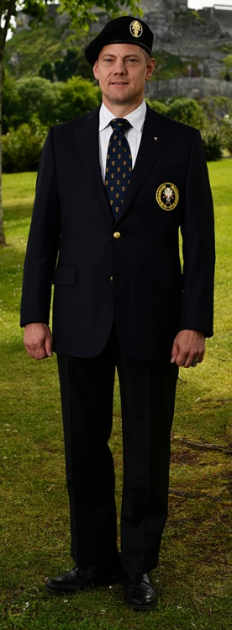
Dress Code for Others
4th Degree Members/Observers

New uniform.
Black tuxedo with social baldric
during ceremony
Dark suit with tie is acceptable

Honor Guard
New Uniform for ceremony, white gloves, and swords

Flag Bears
No Swords

Color Guard Escorts
New Uniform for ceremony, white gloves, and swords

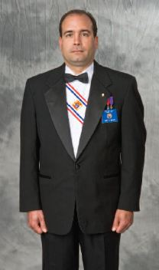



We need you to join the Color Corps.
Of the 4th Degree.
The Color Corps. Is made up of the Honor Guard and Color Guard members who
serve the 4th Degree Assemblies by:
- Presenting & Posting the flag of our nation at Knights of Columbus events
- Stand as part of an honor guard for brother Knights who pass away
- Form honor guards for Priests celebrations, like anniversaries
- Participate in Honor Guards at your Bishops request, like the dedication of new Church’s
- Take part in Honor Guards for Holy Relics
- Being part of the 4th Degree Exemplification team
- Honoring our Veterans at Memorial Day celebrations
The 4th Degree uniform package includes:
- Blazer/Coat
- Trousers
- Tie
- Beret & Badge
- $449.00
- Sword & baldric sold separately at
KofCsupplies.com

To order the official uniform:
Call 833/562-4327 or go to
KOFCUNIFORM.COM
District Master of Georgia
Name
Address

Phone

Email

For sizing, visit our website or contact a sales representative for assistance.

